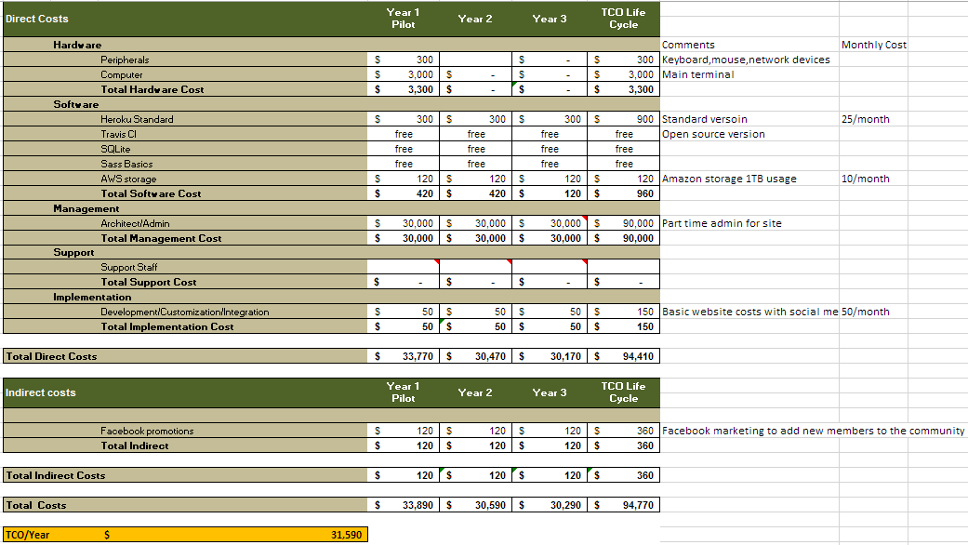To show our clients how much it would be to implement a site I did a ROI although the theme is Community organisation which isn’t looking for a direct profit I can still show the costs involved such as general website costs, developing costs, licensing costs, marketing costs and admin costs. The table below shows a summary of the total direct and indirect costs.

<https://www.heroku.com/pricing>

<https://travis-ci.com/plans>

<https://www.sqlite.org/different.html>

<https://aws.amazon.com/s3/pricing/>

<http://sass-lang.com/guide>

<https://www.atilus.com/what-does-a-website-cost-web-site-development-costs/>